Dear JSL Members and Parents/Sponsors,

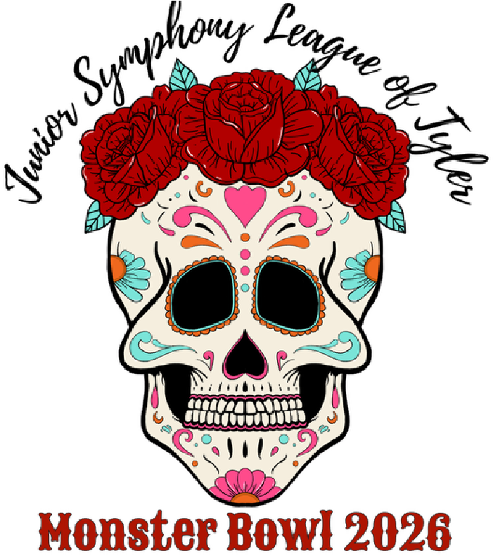
Sunday, November 1st, the Junior Symphony League will host our
ONLY annual fundraiser – the JSL Monster Bowl 2026 at Green Acres Bowling Alley from 6-8 p.m. All proceeds from Monster Bowl directly benefit East Texas Youth Orchestra, Women’s Symphony League scholarships, and local music education. In 2025, proceeds donated to these worthy endeavors exceeded $10,000.

Below are the details for the event:
- JSL members will enjoy bowling, pizza, drinks, a costume contest, door prize drawings, a DJ, and a candy bar. Attendance is mandatory as part of the JSL commitment.
- Each member is required to raise at least $50 in pledges or sponsorships, which will earn the member one (1) Windsor credit. Up to two (2) additional Windsor credits may be earned by raising two additional $50 pledges. The maximum that can be earned based on pledges collected is three (3) credits.
- Each member may bring 1 guest for $15. All guests should be pre-registered. The member will receive one (1) Windsor credit for bringing a guest.
- Each JSL member will receive one (1) Windsor credit for wearing a costume and one (1) additional credit will be given for the best girl, boy, and couple costumes.
- We are offering a Monster Bowl 2026 t-shirt for purchase. The purchase of one t-shirt will earn you one (1) Windsor credit. The purchase of two t-shirts will earn you two (2) credits. While you may purchase as many t-shirts as you like, the maximum credits that can be earned based on t-shirt purchases is two (2) credits. T-shirts will feature 2026 Monster Bowl theme, Dia De Los Muertos, on the front and class rosters on the back. The purchase price of t-shirts is $20. Please place orders by September 18th, after that purchases will be subject to availability.

In summary, your JSL member can receive many Windsor credits by participating fully in this event!

Pledge forms and sponsor contribution forms are included at the end of this packet. Although we are offering the option to fill out and mail in pledge cards, we prefer that your JSL members collect the money from their sponsors and then make the pledge payment online. Please go online to www.wsltyler.org and choose Junior Symphony League then scroll down to Monster Bowl.

We would love to have the entire evening completely underwritten with donations above and beyond the students’ pledges, so that 100% of the money that they raise will directly benefit music education. Sponsors may have their logo printed on the t-shirt or displayed on the food table if desired. Please consider contributing at one of the levels on the attached sheet. UPDATE: Event and T-shirt sponsors can designate a student to receive Windsor credits for their contribution. Windsor credits will be awarded 1 credit per $50 up to a total of 3 credits per student.

We are looking forward to a fun evening! Please call us with any questions you may have.

Sincerely,
Margo Hillin, Stacy Watson, and Amy Meads
JSL 2026 Monster Bowl Co-Chairs Margo: (903) 343-7355
Stacy: (903) 205-9594
Amy: (760) 277-5373


Use this QR Code to:
- Buy Guest Tickets
- Buy a T-Shirt(s)
- Make a Pledge

Or. go online to www.wsltyler.org

JUNIOR SYMPHONY LEAGUE MONSTER BOWL REQUIRED PLEDGE AND GUEST INFORMATION

JSL Member Name: _______________________________________ Grade: Junior Senior

Pledge Information:

To promote music education in our community, my goal is to obtain a minimum of $50 in pledges for my participation in the Junior Symphony League Monster Bowl.

DONOR NAME AMOUNT (Must total at least $50)

- $

- $

- $

You will receive one (1) Windsor award credit for this pledge card totaling $50 or more. For each additional pledge card of $50, you will receive 1 credit – for a maximum of 3 credits towards the Windsor Award.

Guest Information:

Name of Guest: ________________________________________________________
Please include $15 for your guest.

T-shirt Order:

Sizes and number of shirts: ________________________________________________
Each shirt is $20.

If you wish to return this completed form and a check for your pledges and/or guest fees, please do so by October 23rd. Please place T-shirt orders by September 18th to ensure availability. Submit to the following address:
Amy Meads
JSL 2026 Monster Bowl Co-Chair
2017 Hollystone Drive Tyler, TX 75703

You may also make payments for your pledges and guest ticket online by visiting www.wsltyler.org and clicking on the JSL page and scrolling down to the Monster Bowl information.
Thank you in advance for all your hard work and participation!!

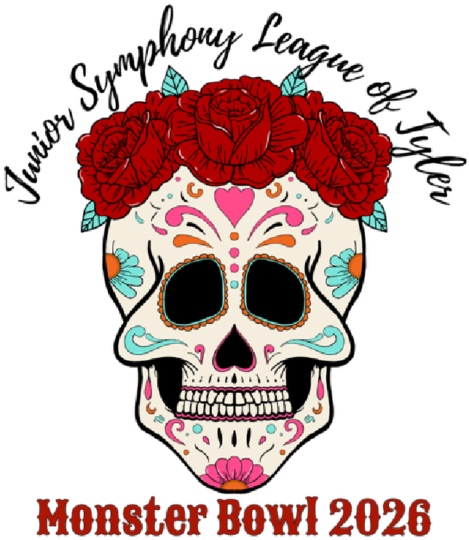

JSL Monster Bowl 2026
Sunday, November 1st 6:00-8:00pm Green Acres Bowling Lanes

EVENT UNDERWRITING CONTRIBUTION FORM

Name (Contact & Business):

Address, City, State, Zip:

Phone/Email:

There are multiple ways to sponsor the JSL MONSTER BOWL:
T-shirt sponsor and have your business logo printed on the back of the T-shirt along with the student rosters. Students purchase and sell T-shirts as part of the fundraiser. T-shirt sponsors are subject to limited availability for logo and must be submitted with logo file (*.ai, *.png, or *.pdf) by September 18, 2026, to Amy Meads.

_______ 50% T-shirt Sponsor (50% logo space) for $500

_______ 25% T-shirt Sponsor (25% logo space) for $270

Event sponsor and have your business logo displayed on 8 ½” x 11” cardstock on the food table. Please submit logo file (*.png or *.pdf) by October 23, 2026.

_______ Any amount, please indicate amount

If you have any questions, please reach out to Amy Meads, JSL 2026 Monster Bowl Co-Chair, (760) 277-5373 or amymeads@outlook.com.

Please return this form, along with you check payable to JUNIOR SYMPHONY LEAGUE to:

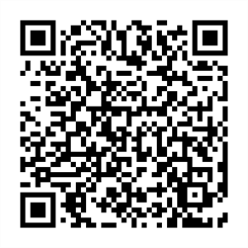
Amy Meads Use this QR code to
JSL 2026 Monster Bowl Co-Chair Sponsor Monster Bowl:
2017 Hollystone Drive Also, you may pay online
Tyler, TX 75703 at www.wsltyler.org

