Dear local business,
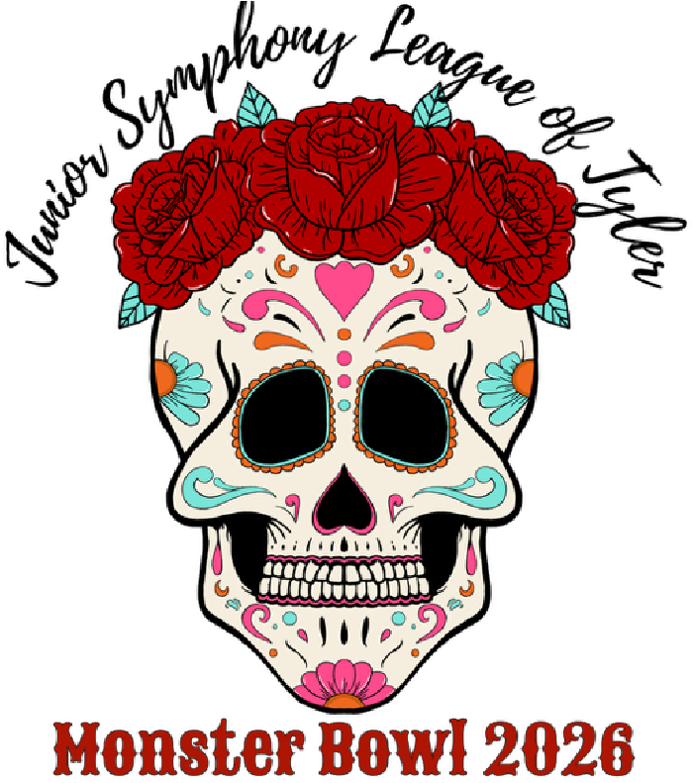
On the evening of Sunday, November 1st, our Junior Symphony League classes of 2027 and 2028 will gather in celebration as they come together to bowl, wear colorful costumes, dine on pizza, enjoy great music, and win fabulous door prizes. They will be participating in their only annual fundraiser – the JSL Monster Bowl, a vibrant Dia de los Muertos fiesta.
Each JSL member is required to collect $50 in pledges for this
colorful and heartfelt event, which will all be donated to the East Texas
Youth Orchestra and to the Music Education Funds of the Women’s Symphony League. In 2025, proceeds donated to these worthy endeavors exceeded $10,000.
We are looking forward to another beautifully spirited year and need your help! Our goal is to underwrite the cost of this electrifying event, so that 100% of the money raised through JSL member pledges may be donated. Your generous contributions will go toward event expenses such as bowling alley rental and DJ fees. In addition, this year we are including a Monster Bowl T-shirt for the Junior Symphony League members to purchase. We are seeking T-shirt sponsors. Sponsorship will include company logo printed on the T-shirts.

To make it easy, please go online to www.wsltyler.org and choose Junior Symphony League then scroll down to Monster Bowl. Please return the enclosed form, along with your check payable to the JUNIOR SYMPHONY LEAGUE to:
Amy Meads Use this link or QR Code to JSL 2026 Monster Bowl Co-Chair Sponsor Monster Bowl:
2017 Hollystone Drive You may also pay online Tyler, Texas 75703 at www.wsltyler.org

The Monster Bowl is a fun evening for the JSL members to enjoy while learning the value of volunteering and the importance of fundraising. We are looking forward to a brilliantly colorful night in the spirit of Dia de los Muertos. Any amount is deeply appreciated—every donation helps hour these hard-working students. With membership at over 500, if every WSL member contributed just $10, we could easily cover the cost of the event.
Thank you for your kindness and support. Please call either of us if you have any questions!
With Gratitude,
Margo Hillin, Stacy Watson, and Amy Meads JSL 2026 Monster Bowl Co-Chairs
Margo: (903) 343-7355
Stacy: (903) 205-9594
Amy: (760) 277-5373

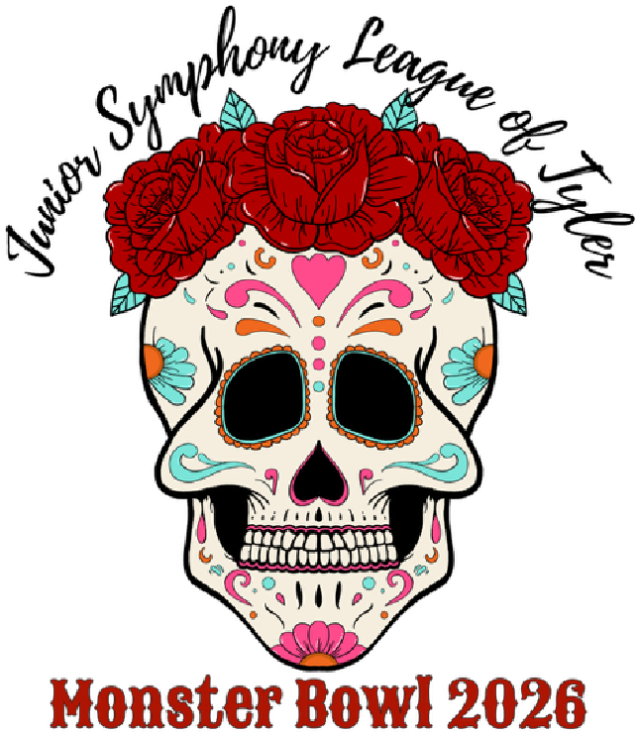

JSL Monster Bowl 2026
Sunday, November 1st 6:00-8:00pm Green Acres Bowling Lanes

EVENT UNDERWRITING CONTRIBUTION FORM

Name (Contact & Business):

Address, City, State, Zip:

Phone/Email:

There are multiple ways to sponsor the JSL MONSTER BOWL:
T-shirt sponsor and have your business logo printed on the back of the T-shirt along with the student rosters. Students purchase and sell T-shirts as part of the fundraiser. T-shirt sponsors are subject to limited availability for logo and must be submitted with logo file (*.ai, *.png, or *.pdf) by Thursday, September 18, 2026, to Amy Meads.

_______ 50% T-shirt Sponsor (50% logo space) for $500

_______ 25% T-shirt Sponsor (25% logo space) for $270

Event sponsor and have your business logo displayed on 8 ½” x 11” cardstock on the food table. Please submit logo file (*.png or *.pdf) by October 23, 2025.

_______ Any amount, please indicate amount

If you have questions, please reach out to Amy Meads, JSL 2026 Monster Bowl Co-Chair, (760) 277-5373 or amymeads@outlook.com.

Please return this form, along with your check payable to the JUNIOR SYMPHONY LEAGUE

Amy Meads
JSL 2026 Monster Bowl Co-Chair Use this link or QR Code to
2017 Hollystone Drive Sponsor Monster Bowl:
Tyler, Texas 75703

You may also pay online at www.wsltyler.org

